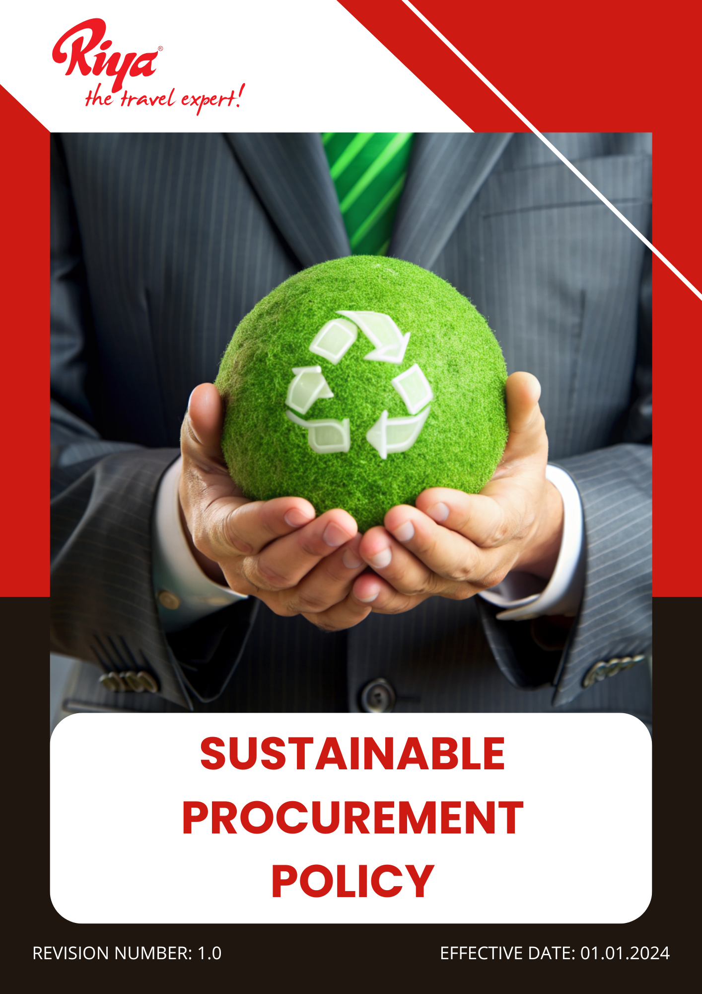

Contents
~ Overview 3
~ Purpose 3
~ Applicability 3
~ Policy statement 4
~ Our Focus Areas 4
~ Our Strategic Approach 4
~ Governance of this Policy 6
~ Responsibility for this Policy 6
~ Reporting 7
~ Continuous Improvement 8
~ Review Mechanism for this policy 9

Overview
At Riya Travels and Tours Pvt Ltd (Group), we are committed to responsible sourcing and procurement practices that align with our environmental and social sustainability goals. As a leader in the travel industry, we recognize the impact of our supply chain on the environment and society. Our Sustainable Procurement Policy aims to minimize our ecological footprint by prioritizing eco-friendly products, ethical sourcing, and suppliers that adhere to environmental and social responsibility standards. Through responsible purchasing, waste reduction, and partnerships with sustainable vendors, we strive to support fair trade, reduce carbon emissions, and promote resource efficiency. This policy outlines our approach to integrating sustainability into procurement decisions, ensuring compliance with environmental regulations, and fostering a culture of responsible consumption within our organization and across our supply chain.

Purpose
- Source products and services with a reduced environmental footprint, including energy-efficient equipment, recycled materials, and eco-friendly office supplies.
- Partner with suppliers committed to reducing carbon emissions, using renewable energy, and implementing waste reduction strategies.
- Ensure ethical labor practices and compliance with local and international human rights and environmental standards among suppliers and vendors.
- Encourage partnerships with sustainable airlines, eco-friendly hotels, and transportation providers to promote responsible travel options.
- Integrate circular economy principles by promoting product reuse, recycling, and sustainable disposal within office and travel services.
- Support small and local businesses to strengthen community impact and enhance supply chain resilience.
- Establish sustainability criteria for supplier selection and regularly assess performance to ensure alignment with company values and environmental goals.

Applicability
This Sustainable Procurement Policy is applicable across all operations, business functions, and services of Riya Travel and Tours (India) Pvt Ltd (Group), covering all global locations, including corporate offices, registered offices, branch locations, subsidiaries, joint ventures, and associated supply chain activities. It applies to all employees, workers, contractors, and stakeholders connected to Riya Travel and Tours (India) Pvt Ltd (Group), whether directly or indirectly, and mandates strict adherence and accountability at every level.

Policy statement
Riya Travels and Tours Group is committed to responsible and sustainable procurement practices that support environmental and social well-being. We prioritize ethical sourcing, eco-friendly products, and partnerships with suppliers who adhere to sustainability principles. Through responsible purchasing, waste reduction, and supply chain transparency, we aim to minimize environmental impact, promote fair trade, and contribute to a more sustainable future.

Our Focus Areas
- Promoting ethical and responsible sourcing across all procurement activities is a key priority.
- Ensuring supplier compliance with environmental, labor, and human rights standards remains a central focus.
- Encouraging partnerships with suppliers that follow sustainable practices and reduce environmental impact.
- Supporting local and small businesses to enhance community engagement and economic growth.
- Reducing waste and promoting circular economy principles in the procurement process is an ongoing commitment.
- Advocating for sustainable procurement practices and encouraging eco-friendly supplier initiatives is integral to our mission.

Our Strategic Approach
- General Targets
- We strive to achieve 100% coverage of our suppliers in sustainability self-assessments and on-site audits to strengthen supply chain transparency and improve overall ESG performance by FY 2027-28, with FY 2022-23 as the baseline year.
- We are committed to ensuring that 100% of our suppliers sign the "Supplier Code of Conduct" to create a culture of accountability and integrity by FY 2027-28, reinforcing ethical and sustainable practices.
- We aim to incorporate additional ESG criteria into supplier contracts, fostering long-term alignment with global best practices, every 2–3 years or as mandated by evolving government regulations and industry standards.
- We strive to conduct ESG performance reviews for 100% of suppliers to monitor compliance, identify gaps, and drive continuous improvements in supplier performance annually, starting from FY 2024-25.
- We will implement corrective action plans for all non-compliant suppliers to strengthen supply chain integrity and promote accountability, achieving a 90% resolution rate within 12 to 15 months, starting from FY 2024-25.
- Initiatives for Ethical Sourcing and Supplier Responsibility
- To promote responsible sourcing, the company aims to increase sourcing from certified ethical suppliers, ensuring that our procurement decisions reflect ethical values and sustainability commitments, by 30% by FY 2027-28 from the baseline year FY 2022-23.
- We aim to conduct annual supplier audits to strengthen accountability and build a responsible supply chain, covering 100% of Tier 1 suppliers globally by FY 2027-28.
- We aim to provide comprehensive training on responsible sourcing to equip our team with the knowledge and skills to make informed, ethical decisions in procurement, ensuring 100% participation by FY 2027-28.
- Initiatives for Addressing Environmental Issues through Sustainable Procurement
- We aim to increase the number of suppliers with environmental certifications, such as ISO 14001, encouraging suppliers to adopt globally recognized environmental management systems, by 50% by FY 2027-28 from the baseline year FY 2022-23.
- We aim to conduct onsite ESG audits for 100% of our suppliers, ensuring alignment with environmental and social standards while promoting sustainable business practices, by FY 2027-28 from the baseline year FY 2022-23.
- Efforts will be made to increase the number of local suppliers supporting the transition to low-carbon logistics and reducing our environmental footprint, by actively reducing greenhouse gas emissions from transportation by 10% by FY 2027-28 from the baseline year FY 2022-23.
- Steps will be taken to train all procurement staff on environmental procurement practices, fostering a culture of environmental responsibility and sustainable decision-making, targeting 100% workforce participation by FY 2027-28 from the baseline year FY 2022-23.
- Initiatives for Promoting Fair Labor Practices and Human Rights
- We aim to ensure 100% of our suppliers comply with fair labor practices (wages, working conditions), strengthening labor rights and improving working conditions across our supply chain, by FY 2027-28 from the baseline year FY 2022-23.
- We aim to increase the number of suppliers with social responsibility certifications (e.g., SA8000, Fair Trade), reinforcing adherence to international labor and ethical standards, by 50% by FY 2027-28 from the baseline year FY 2022-23.
- Efforts will be made to increase procurement from minority-owned and women-owned businesses through a dedicated supplier diversity program, fostering inclusivity and economic empowerment, by 10% by FY 2027-28 from the baseline year FY 2022-23.
- We strive to ensure 100% of our suppliers hold recognized certifications (e.g., SA8000, Fair Trade) for labor practices, strengthening our commitment to social responsibility and supplier integrity, by FY 2027-28 from the baseline year FY 2022-23.
- Steps will be taken to train all procurement staff on social issues related to fair labor and diversity, empowering employees to support ethical and inclusive procurement decisions, targeting 100% workforce participation by FY 2027-28 from the baseline year FY 2022-23.

Governance of this Policy
The governance of this Sustainable Procurement Policy will be overseen by a designated Procurement Compliance Officer. This individual will ensure adherence to responsible sourcing guidelines, monitor procurement practices, and assess supplier compliance with sustainability and ethical standards. They will collaborate with all departments, suppliers, and stakeholders to drive sustainable purchasing decisions, implement best practices, and align procurement operations with corporate sustainability goals. Regular audits, training sessions, and policy updates will be conducted to foster continuous improvement. The Procurement Compliance Officer will be responsible for integrating sustainability into procurement strategies and ensuring long-term responsible sourcing.

Responsibility for this Policy
- Sustainability Officer
- Responsible for overseeing and review the implementation of the policy.
- Tracking progress on sustainability goals.
- Ensuring compliance with environmental regulations, and promoting continuous improvement.
- Senior Management
- Provides strategic direction, allocates necessary resources
- Integrates sustainability into corporate decision-making to drive responsible procurement practices.
- Employees
- Expected to support sustainable procurement by minimizing waste and making responsible purchasing decisions.
- Actively participate in training programs and initiatives to enhance sustainable sourcing awareness.
- Procurement Team
- Ensures that all purchases prioritize sustainability by selecting eco-friendly, ethically sourced products and working with responsible suppliers.
- Regularly evaluates supplier performance to ensure compliance with ethical and environmental standards.
- Facility Management
- Implements Monitors procurement spending to align with sustainability goals.
- Ensures financial accountability in ethical sourcing practices.

Reporting
- Internal Reporting
- The Procurement Compliance Officer will submit quarterly reports to senior management on policy implementation, supplier performance, and key sustainable procurement metrics.
- Department heads will provide updates on procurement challenges, sustainability initiatives, and corrective actions taken.
- Compliance Reporting
- Regular audits will be conducted to ensure adherence to environmental regulations and corporate sustainability commitments.
- Non-compliance incidents will be documented, investigated, and addressed through corrective measures.
- External Reporting
- An annual sustainability report will be published to communicate the company’s environmental impact, progress on targets, and future commitments.
- Reports will be shared with relevant stakeholders, including regulatory bodies, business partners, and customers.
- Employee and Stakeholder Feedback
- A reporting mechanism will be established for employees and stakeholders to raise concerns or suggest improvements related to procurement practices.
- Feedback will be reviewed regularly to enhance the effectiveness of the policy.

Continuous Improvement
We are committed to continuously enhancing our sustainable procurement efforts. We will regularly evaluate our sourcing strategies, integrate innovative and eco-friendly procurement solutions, and refine our policies based on industry advancements and stakeholder feedback. Through ongoing training, supplier engagement, and strategic partnerships, we will ensure sustained progress in responsible sourcing while adapting to evolving sustainability and ethical sourcing challenges.

Review Mechanism for this policy
The Procurement Compliance Officer will review this policy every year or as needed to ensure its relevance and effectiveness. In collaboration with senior management and key stakeholders, they will assess compliance, evaluate procurement practices, and identify areas for improvement. Updates will be made based on regulatory changes, supplier performance, and sustainability best practices to ensure continued alignment with corporate goals and ethical sourcing standards.

Effective Date: 01.01.2024
Last Review Date: 01.01.2025
Next Review Date: 01.01.2026



Approved By – Director HR
(Riya Travels and Tours (India) Pvt ltd (Group))
Employee Acknowledgement Form
I acknowledge that I have received, read, and understood the Sustainable Procurement Policy. I understand my responsibility to comply with the policy’s guidelines and actively support responsible sourcing, ethical procurement, and sustainability efforts within my role. I commit to prioritizing eco-friendly products, minimizing waste, and ensuring ethical supplier partnerships in line with the company’s sustainability goals. I also recognize that the policy will be reviewed periodically, and I will stay informed about any updates. By signing this form, I confirm my commitment to upholding the principles outlined in the policy.
Employee Name: Mr. Raju Jadhav
Department: Hotel Operations
Designation: Sr. Executive

Date: 03/01/2025
Signature:

